React DEMO

React

I have created a home component class declared it as export class which extends react component and implements fetchdatasamplestate

State has datamodel array and loading as Boolean as follows:

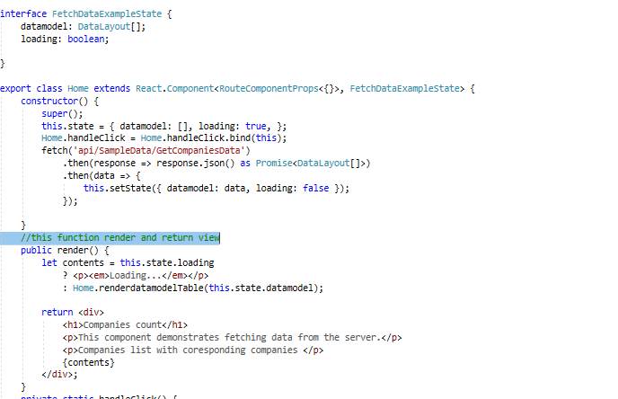

Renderdatamodeltable is a function with renders table and return it as follows:

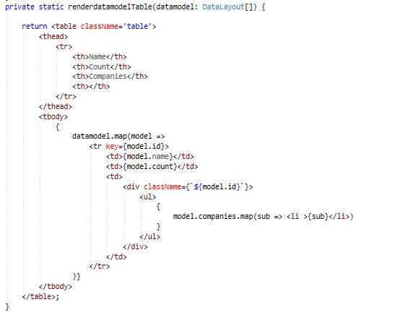

Routing

Routes are defined in routes.tsx as follows:

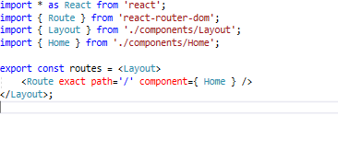

ASP .NET core

Controller Section

I have created sample data controller which executes asynchronously and return the data viewmodel as

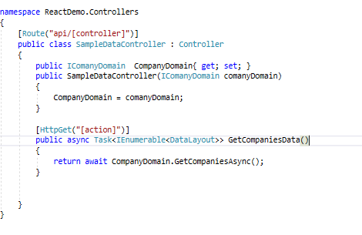

The company domain is injected in it. This is declared in startup and added as scoped.

Domain Section:

The domain has basically all the backend processing and only domain is exposed to controllers

We have company Domain

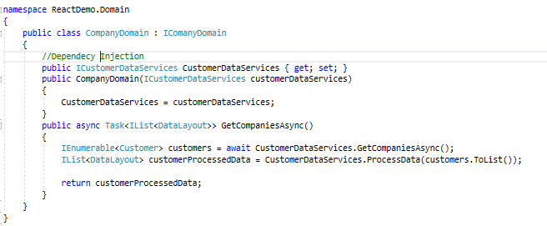

Which implements ICompanyDomain:

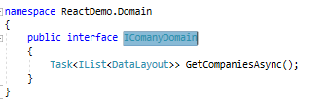

CustomerDataservices are basically injected via constructor injection method. The dependency injection work as we have to add them to scoped in startup as

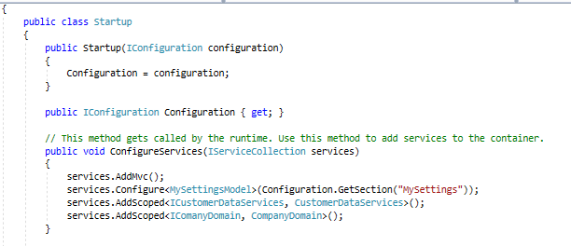

Services Section:

All the data processing is done in services :

We have Api services partial class which has all the request

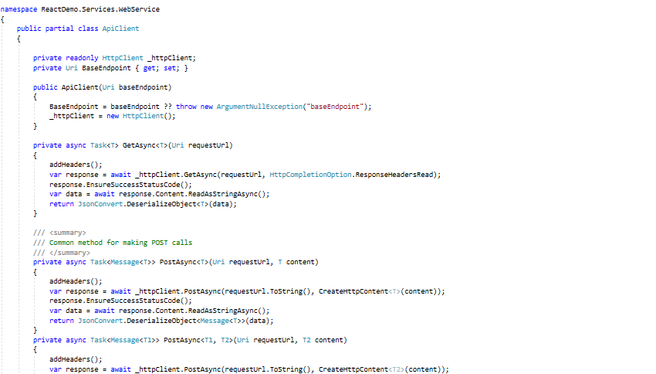

I created partial class with filename CustomerApiClient.cs which has binding of data and customer request url with it.  
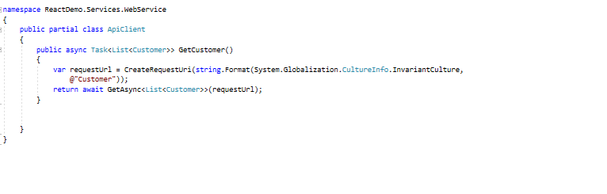

ApiClient instance is generated by ApiClientFactory class as :

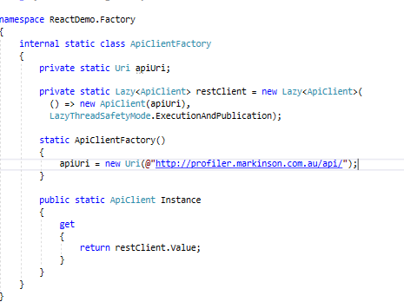

I have create CustomerDataService Which implements ICustomerDataService Which has declration of functions as

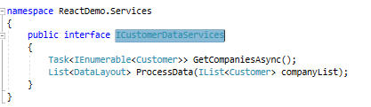

And CustomerDataService class as

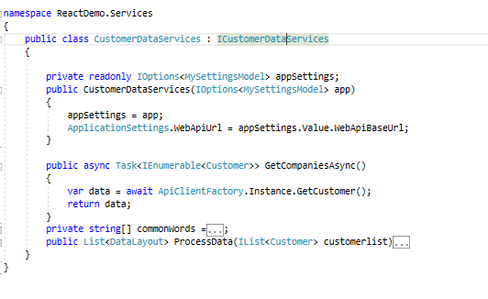

The algorithm for processing data is as following:

1. First I get all the customers data from the service.
2. Then I selected only company names and then I split them into words to check maximum repeating word like is, am, are.
3. Then I removed common words and the words which has length lesser than three.
4. Then I store all the words into dictionary and selected the distinct and assigned value as count of their occurrences.
5. Then I took only 5 elements of maximum repeating items in dictionary by ordering it descending.
6. Then I populated DataLayout class which is basically my viewmodel.
7. Then I order it descending first by count and then by name.

Comments are given in code:

Client